




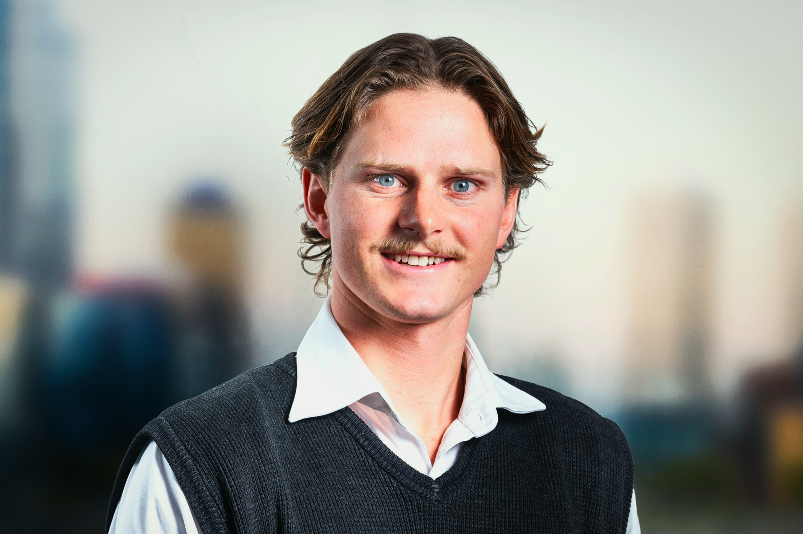

Personal Skills
- Client Engagement
- Collaboration
- AI & Workplace Efficiency
- Communication & Clarity
- Enthusiastic
- Fast Learner
- Flexible & Adaptable

Education
Bachelor of Science at University of Western Australia
Mechanical Engineering
Data Science

Hale School â€“ Western Australia
2013 - 2019

Technical Skills
- SAP
- Python, SQL & MATLAB
- React / TypeScript & FastAPI
- Databricks & PostgreSQL
- AWS, Azure & Docker
- Power BI, Power Apps & Git

Professional Overview
I am a consultant engineer in Deloitteâ€™s Strategy, Risk and Transactions practice, within the specialist asset management team. My work centres on maintenance strategy optimisation, reliability analysis and the maintenance master data that underpins both.
FORTESCUE â€“ ASSET MAINTENANCE SPECIALIST
I heard about this role through my brother, who works at Fortescue, and it stood out immediately. Most of my work sits in maintenance strategy optimisation and the master data underneath it â€“ FLOC hierarchies, BOM validation, material classification and work order coding â€“ because a strategy is only ever as good as the data it runs on. The past two years have been spent turning messy SAP and operational data into reliability insight, defect elimination and better work management. Fortescueâ€™s approach of leading through doing, and the chance to build proof-of-concept tools alongside software and data engineers rather than hand requirements over, is exactly the environment I am looking for.

Work Experience
Deloitte Touche Tohmatsu Limited Australia
Jan 2024 â€“ Present
See Project Activities Below
Global Iron Ore Producer (Pilbara)
Maintenance System Optimisation (MSO), Consultant Engineer
January 2026 - Current

As part of a multi-disciplinary delivery team, I helped build a full-stack, cloud-native AI application that modernises and automates maintenance strategy processes across Heavy Mobile Equipment (HME) and Fixed Plant (FXP) assets for a global iron ore producer. It replaces fragmented, manual engineering workflows with AI-augmented data review, statistical reliability modelling and data-driven maintenance optimisation, integrating Databricks and SAP work order data for traceability through to validated maintenance recommendations. My contribution spanned reliability modelling, application features and data visualisation, alongside the teamâ€™s LLM specialists. The product is rolling out to production, with projected annual savings of $35 million.
- Maintenance master data - human-in-the-loop review of AI-generated material classifications, FLOC BOM validation and work order classification.
- Reliability engineering - Weibull analysis, MTBF/MTTF calculation, Asset Health Index scoring, component age analysis and replacement projection modelling.
- Maintenance strategy optimisation - turning reliability outputs into data-driven maintenance tactic and component replacement recommendations for engineer sign-off.
- Full-stack development - React/TypeScript front-end features and Python/FastAPI REST endpoints.
- Data engineering & cloud - Databricks Gold-layer products and SAP work order data into a PostgreSQL database, deployed on Azure Container Apps.
- Data visualisation - Weibull curves, age analysis timelines and health index dashboards using Plotly.js.

(+61) 477477991
Murraylewin91@gmail.com
Cottesloe, Western Australia
Linkedin Murray Lewin

Contact Details

Murray
Lewin
Consultant Engineer

Volunteering
Ronald McDonald House â€“ Big Brother Program (2018)
Supported and engaged with chronically ill children from rural and remote areas during hospital stays.

Ngalangangpum School â€“ Warmun Community
Engaged with Indigenous students in a remote school, fostering cultural understanding and supporting education equity.

Mt Hawthorn Special Education Unit
Assisted primary students with diverse learning and physical disabilities in their development.

Quintilian School
Supervised sports, assisted in classes, and built lasting friendships through the buddy program.

Sienna Centre â€“ Holy Rosary Primary School
Assisted classroom activities to enhance social skills for children with disabilities.

Referees
Professional references are available upon request. Please feel welcome to get in touch if required.
Role: Owner / Snr Manager
Contact: 0402 214 515

Achievements
- Duke of Edinburgh Bronze Medallion

Continued Project Experience â€“ Deloitte Touche Tohmatsu Limited
Global Gold Mining Operator
Group Asset Management Framework (Phase 1 and 2), Consultant Engineer
September 2025 â€“ January 2026

Group Asset Management Framework
Rolled out the group Asset Management Framework and System Definition. Defined Key Practice Areas, system requirements and documentation layout for a global gold mining operator. Worked with the central asset management team across Australia, Chile, South Africa, Ghana & Canada to identify and align global frameworks.
- Asset Management Framework definition and Key Practice Areas rollout.
- Asset Management System documentation and global standardisation.
- Facilitated international workshops across 5 countries, running sessions with central and site asset management teams.

Global Iron Ore Producer (Pilbara)
Asset Health Index Rollout (Fixed Plant), Consultant Engineer
March 2025 â€“ September 2025

Asset Health Index â€“ Pilbara Fixed Plant Sites
4/3 roster fly-in fly-out rollout and build of an Asset Health Index across two Pilbara sites, covering wet plant assets and low-grade fixed plant.
- Power BI dashboard development to track and communicate asset health scores across sites.
- Engagement with Reliability Engineers and site stakeholders to validate AHI scoring methodologies.
- People engagement and RE collaboration to align the Asset Health Index with site maintenance strategies.

Iron Ore Producer (Pilbara)
Labour Benchmarking Review, Data & Reporting Analyst
January 2025 â€“ March 2025

Labour Benchmarking Review
- Worked with national resources to collect a database of information in order to draw conclusions and summaries on industry standard for labour quantities.
- Direct back-and-forth with client to ensure scope aligned with the desired outcomes and the correct conclusions were made.
- Breaking down each site into major assets using exports from various sources, allowing for accurate comparisons between equivalent datasets (ensuring bias due to resource type/org structure would not affect the end result).

Global Iron Ore Producer (Pilbara)
Asset Management Plans (Substations), Engineering Analyst
September 2024 â€“ December 2024

Asset Management Plans â€“ Fixed Plant Substations
- Report Building and collation of large data, utilising appendices and other tools to improve reading ease.
- Substation site validation - checking that the correct regulatory precautions are taken in low voltage substations.
- Recommendations are made based on historical costing and Changeout breakdown of assets - ensuring that the best measures are taken to break down each substation in scope.

Continued Project Experience â€“ Deloitte Touche Tohmatsu Limited
Global Iron Ore Producer (Pilbara)
Asset Management Uplift Programme, Graduate Team Member
June 2024 â€“ September 2024

Asset Tactics Review â€“ Pilbara Operations
- Defect elimination - bad actor review identifying the worst performing site assets on the basis of downtime and associated criticality.
- Work management - changeout analysis of SAP PM01, PM02 and PM03 notifications to find incomplete changeouts, notification timing issues and causes of unnecessary downtime.
- Maintenance strategy documentation - PRT and task description review to find gaps or missing information that would make it difficult for an inspector to assess asset condition.

Previous Experience
Macmahon
Closed Work Order and Parts Reallocation, Storefront
November 2022 â€“ March 2024 â€“ Part time /Ad Hoc

Using SAP to re-issue stock items back into the storefront that werenâ€™t fitted from maintenance orders. Also preparing work orders for fitters and maintenance crew to perform routine fixes.
- Associating parts with SAP ID so that they can be re-issued into stock.
- Collecting work orders and ordering parts to make service kits for the team.
- Operating a stock take which involved reviewing item quantities and adjusting SAP as such.
- Redistribution of hose stockpiles back into stock bins and disposing of out of date hoses to clear backlog.

Prior Experience â€“ University of Western Australia
University of Western Australia
Chatbot UWA Web Design, Group Member
July 2023 â€“ November 2023

Create a UWA questionnaire inspired chatbot that uses the ChatGPT algorithm to answer students questions from a webpage.
- HTML and CSS design by first building a framework with HTML and then adding colour and design with CSS.
- JavaScript actioning which involved strategically adding buttons and capability to the page such as saving user details, passwords and navigation.
- Python AI training was used to create a link between the AI from Amazon cloud servers and the various documents stored in the UWA questionnaire database. A trial and error system was used to bring the AI to ~95% accuracy.
- Final Presentation was made and the product was presented to the UWA Software Engineering board which resulted in an overall positive reaction, and 90% overall project mark.

